* Kubernetes also known as “K8S” is an open-source container orchestration platform developed by google
* It has auto healing capability
* It is designed to automate the deployment, scaling and management of containerized applications across a cluster nodes
* It creates many containers which are replica of other containers, if any containers fails or interruption occurs it will manage

**Kubernetes Architecture**

* Cluster
* Work Node Group
* Work Node
* Deployment File
* Deployment
* Service File
* Service
* Pod
* LB
* Communication between work node group to pods and Client to Cluster

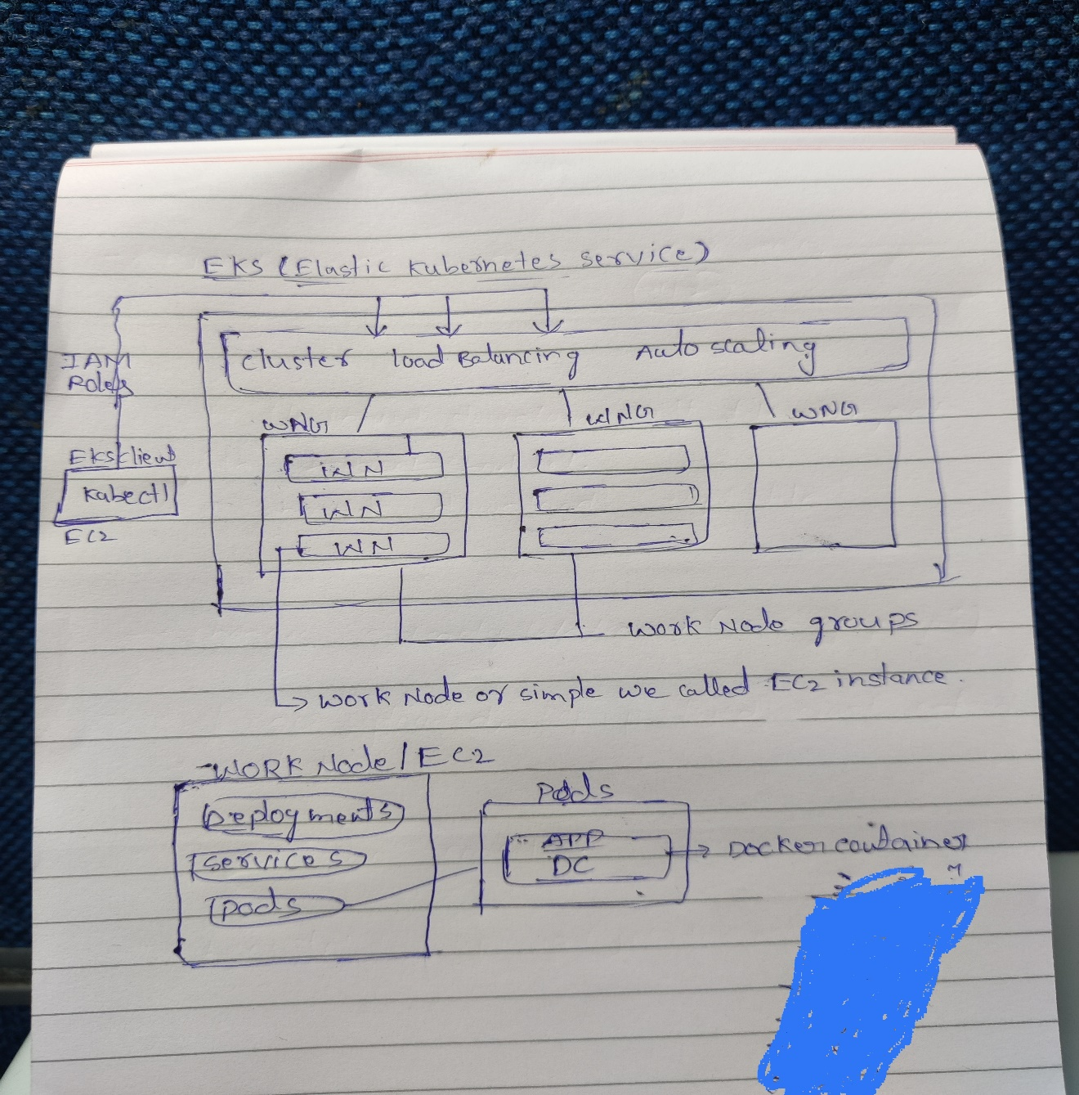

**Deployments**

* Deployments files are written in yaml, in which we specify about the app details
* Deployment file is written and available in client
* When deployment file is applied to cluster/EKS then deployments & pods will be created in work node
* Always deployment file ->1 deployment & N no of pods

-> pods count depends on replica value in deployment file

* When we delete deployment it deletes deployment & respective pods also
* If we want to modify deployment we can edit deployment directly

**Services**

* Service files are written in yaml, in which we specify about, which pod we have to provide access to outside or to which pod this service has to map to accessing
* Service files are available in client, when service file is applied to cluster we get service on top of pods
* In service, we define accessing of pods via cluster IP or Load Balancer
* If load Balancer is defined in service, then load balancer will create in AWS
* Pods are temporary memory it will recreated always based on the user manipulation so every time pods IP address are changed
* To overcome this problem we are using match labels

**RBAC**

* Role based access control is a method of regulating access to computer or network resources based on the roles of individual users within your organization
* RBAC authorization uses the rbac.authorization.k8s.io/v1 API group to drive authorization decisions, allowing you to dynamically configure policies through the Kubernetes API